ASSIGNMENT 2
FINAL LAB TASKS BY OM 2280156
COURSE CC

LAB 9c

Resource Group Created
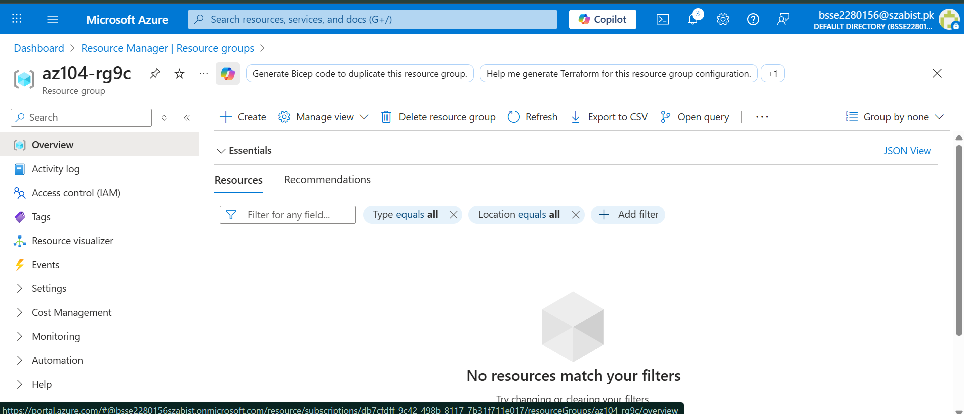

Container App Basic Configuration

Project details
Subscription
Azure for Students
Resource group
az104-rg9c
Name
az104-ca-om
Container Apps Environment (New)
Region
centralindia
Container Apps Environment
managedEnvironment-az104rg9c-9dd2
Log Analytics workspace (New)
workspaceaz104rg9ca987
Virtual network
Default
Zone redundancy
Disabled
Container
Name
az104-ca-om
Image source
Public
Registry login server
docker.io
Image and tag
mcr.microsoft.com/azuredocs/containerapps-helloworld:latest
Command
Arguments
Workload profile type
Consumption
Number of CPU cores
0.5
Memory size (Gi)
1
Ingress settings
Accepting traffic from anywhere
Ingress type
HTTP
Transport
Auto
Insecure connections
Not allowed
Port
80

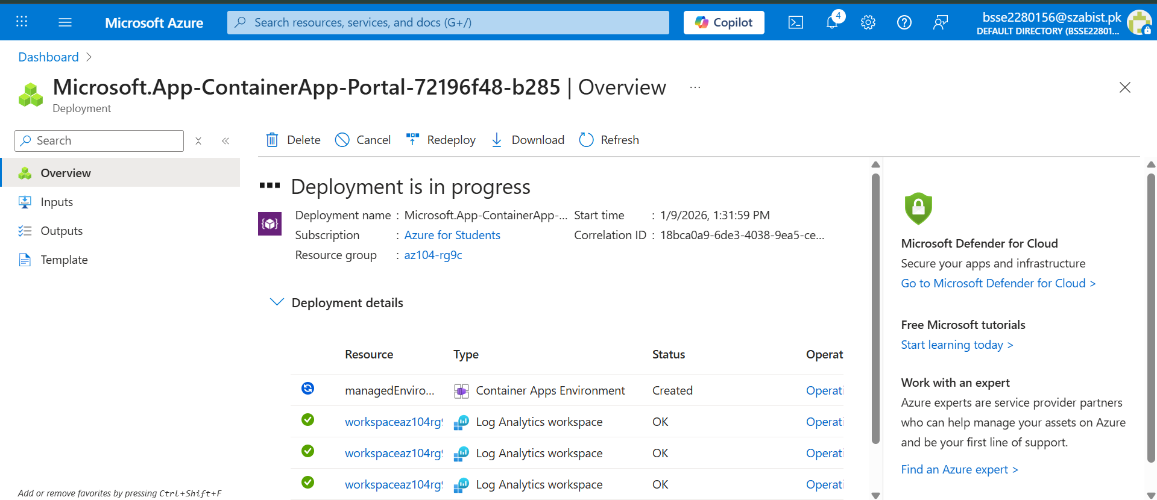

Azure Container App Deployment Successful
Azure Container App Overview

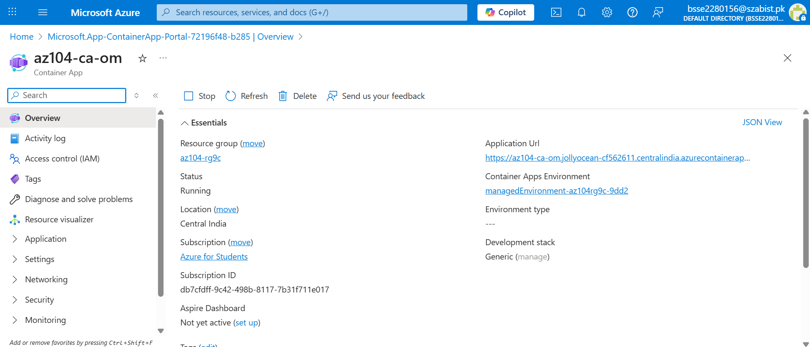

Azure Container App Running Successfully
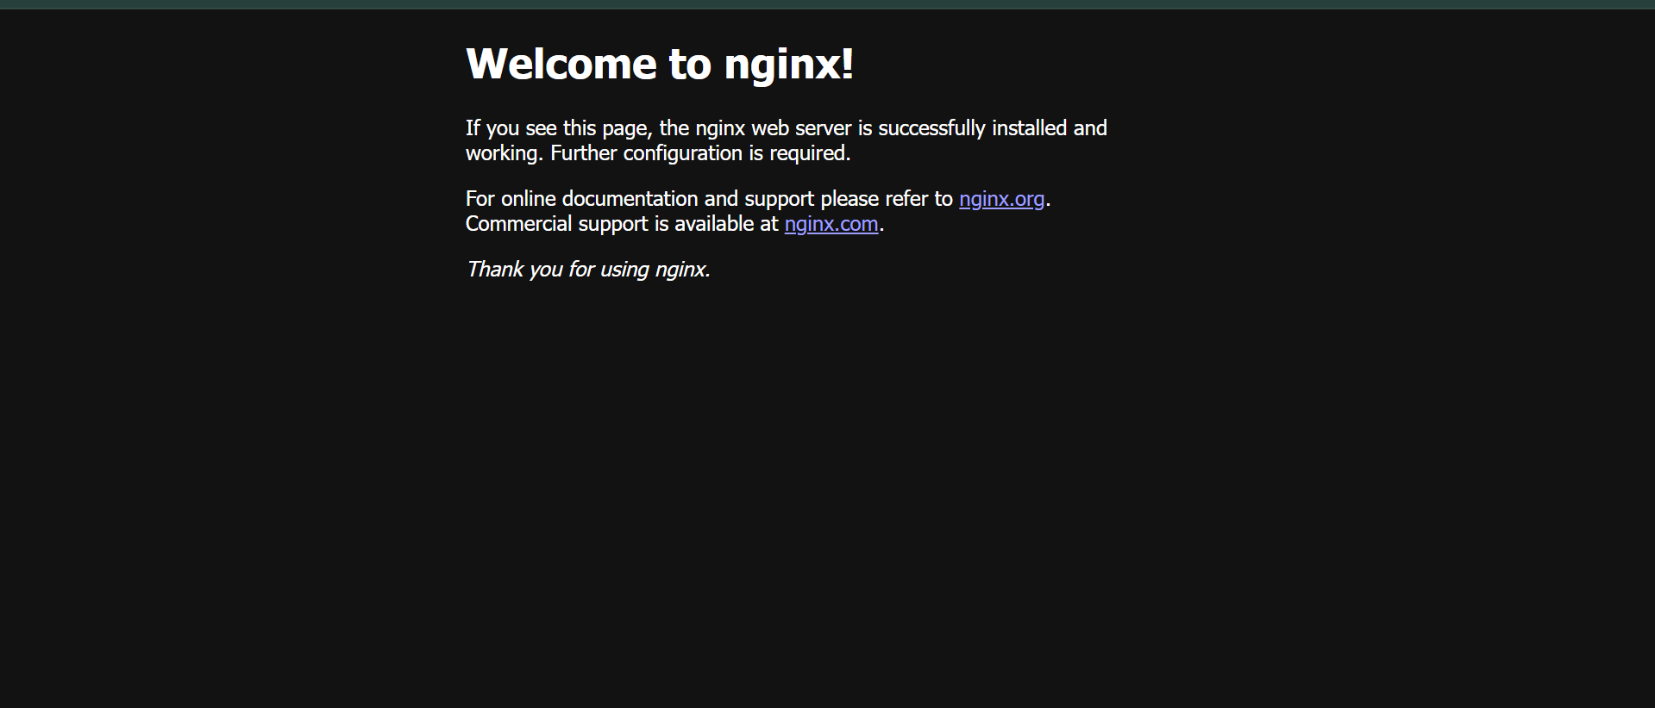

In this lab, an Azure Container App was successfully deployed using a public Docker
image. A container app environment was created, ingress was enabled, and the
application was accessed through its public URL. This demonstrates how Azure
Container Apps can be used to deploy and run serverless containerized applications.

